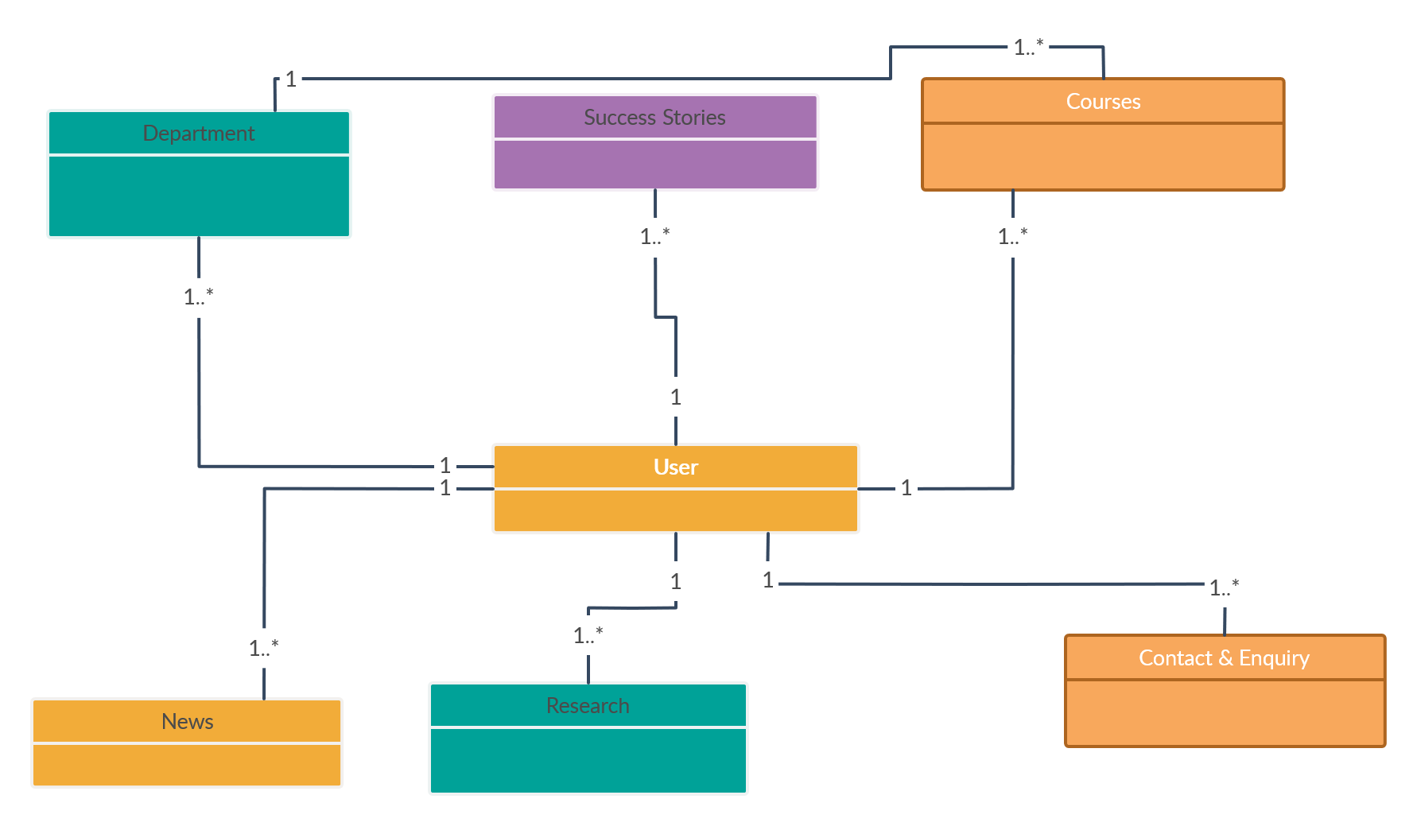

**Figure-1: Initial Class Diagram**